Force Analysis for Simulation and Propulsion

The basic drone forces are analyzed here for future use in the Long Flight Time Buoyant Drone project and can be used to assist in the mechanical design, the vehicle dynamics and aerodynamics models in simulation, power analysis and motor selection. The document will be further updated with new equations for force analysis as needed, while also including more concrete values further in the design process.

Basic Design

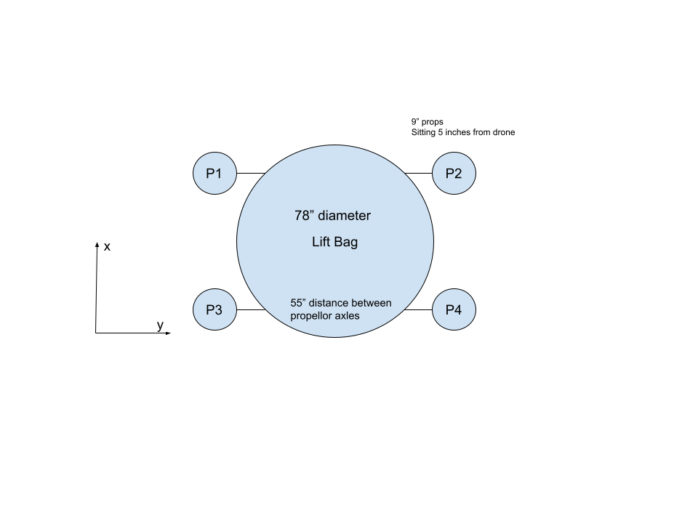

The basic drone design consists of four brushless motors powering propellers on the outside of the lift bag. The propellers point in the x direction and rotate about their y axis. Any angling in y-directions would cause the motors to work against each other, damaging our efficiency. There will also be a vector from the center of mass to the center of buoyancy causing additional torque and lift forces, but that will be a feature of the mechanical design.

Forces (In Body Frame)

To analyze the forces of the drone, several vectors need to be defined, and the center of mass is used for the time being to simplify moment equations. **CMₓ** is the vector from the center of mass to the center of rotation for the motor, where x denotes the motor number. Tₓ will be the scalar throttle of each motor. **MₓP** is the unit vector from the center of rotation for the motor to the center of the propeller. **CMₓ** will be a constant for each propeller decided on the mechanical design, and **MₓP** will vary from each motor depending on its angle and have the value of [cos𝛳, 0, sin𝛳] where 𝛳 = 0 when propeller angle is flat on xy plane. **CB** is the vector from the center of mass to the center of buoyancy.

Propeller Forces

The position of the each of the propellers is given by the sum of **MₓP**\*d+ **CMₓ** where d is the distance between the center of motor rotation and propeller, and the force direction is given by the **MₓP** vector. The force from each motor is given by **MₓP**\*Tₓ. This results in the net propeller forces to be $\sum_{x=1}^{4}{}MₓP*Tₓ$

Lift Forces

The lift forces are to be defined by the buoyancy force and gravity force. The force due to gravity is simply given by the mass of the drone multiplied by the acceleration due to gravity. The lift force is calculated by $F_{B}=ρVg$ where rho is the density of air and V is the volume of the lift bag. The mass of the bag and helium would be considered part of the drone mass, or the mass of helium could be included using the equation $F_{B}={{(ρ}_{air}-ρ}_{helium})Vg$. This results in net lift forces of ${{F{}_{lift}=F}_{g}+F}_{B}$.

Net Forces

The internal forces can then be summed to be $F{}_{internal}=F_{lift}+\sum_{x=1}^{4}{}MₓP_{x}*Tₓ$

Moments

Propeller moments

The moment caused by each motor can be calculated by taking the cross product of the force vector by its positional vector. This results in the moment from the motors to be $M_{mx}=\sum_{x=1}^{4}{}F_{mx}*({{{CM}_{x}+M}_{x}P}_{x}*d)$.

Buoyancy moments

The buoyancy moment is caused by the buoyancy force wanting to be opposite the gravity force, and can be calculated with $M_{buoy}=F_{B}*(R*CB)$. Since the center of mass is used as the center of rotation the vector is 0 so the moment due to the center of mass is zero.

Net Moments

$M_{net}=F_{B}*(R*CB)+\sum_{x=1}^{4}{}F_{mx}*({{{CM}_{x}+M}_{x}P}_{x}*d)$

Drag Force Approximation

Drag is the primary force working against the drone, since the force of gravity is mostly counteracted by the buoyancy of the helium. To simplify the model to achieve ballpark numbers to assist in the design, the entire drone is modeled as a sphere since the bag itself is the largest contributor to drag. Since the drone is operating at low speeds (Re =1,000), the drag coefficient can be approximated to be between 0.4 and 0.5. Then the equation for the drag force is $F_{Drag}=C_{d}⍴V^{2}/2 *A$ where Cd is the drag coefficient, rho is the air density, V is the airspeed, and A is the cross sectional area of the bag. Assuming a drag coefficient of 0.5, a sphere with a volume of 2 cubic meters, and an airspeed of 20mph (5 mph required speed and 15mph headwind, given operating conditions), the max drag force is about 47 newtons. Decreasing the max wind conditions to 10 mph, or wind speed of 15mph, would result in only a drag force of 27N. Since the weight of the drone is about 20 newtons, the bag needs to be streamlined more to achieve noticeable benefit over normal drones. Also an optimization problem should be written and analyzed to find the best buoyancy to drag ratio.

Motor/Propeller Calculations (Static)

The total force magnitude needed to maintain altitude and move against the wind is given by $F_{static}=\sqrt{{(|F}_{lift}|)^{2}+{(|F}_{drag}|)^{2}}$, since we need to handle both at the same time, but altitude adjustment can take priority and slow down top speed slightly. The propulsion of each motor/propeller pair can be calculated with

$F_{prop/motor}=1.225π(.0254d)^{2}/4 * (0.0254RPM_{prop}*pitch*1min/(60sec))^{2}$ and there are a total of four motors. F_static/4 being substituted into F_prop/motor should solve for the needed static conditions for the motor/propeller pairings.

d-diameter- 9in = 0.2286m

$⍴$-air density

RPMprop-RPM of the propeller

Pitch- 4.5in = 0.1143m

d^2* (RPM * pitch * min/sec)^2

m^2* (1/min * m * min/sec)^2 = m^2*m^2 = m^4??



.16Nm

4N 40mm

Prop weight + thrust(3g) = 4N